Annual Dog License Renewal

Property Owners in Casselman
Property owners who registered their dog in CityWide do not need to submit a manual renewal.
  - The renewal fee will be automatically added to your annual tax bill.
  - No action is required in the CityWide portal once the initial registration is completed.
  - The dog tag issued at registration is permanent and does not need to be replaced each year.

Tenants
Tenants must renew their dog license each year through the CityWide portal.
  - Log in to your CityWide account.
  - Open your existing dog license file.
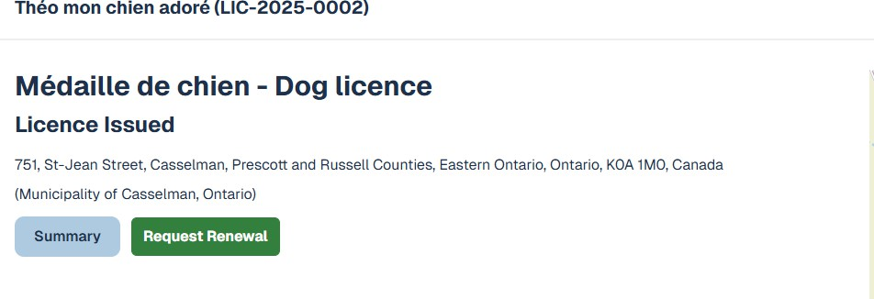
  - Click “Request Renewal”.

  - Review and validate your information (each field must be clicked to confirm).
  - Submit your renewal.
  - Follow the payment instructions sent by the municipality.

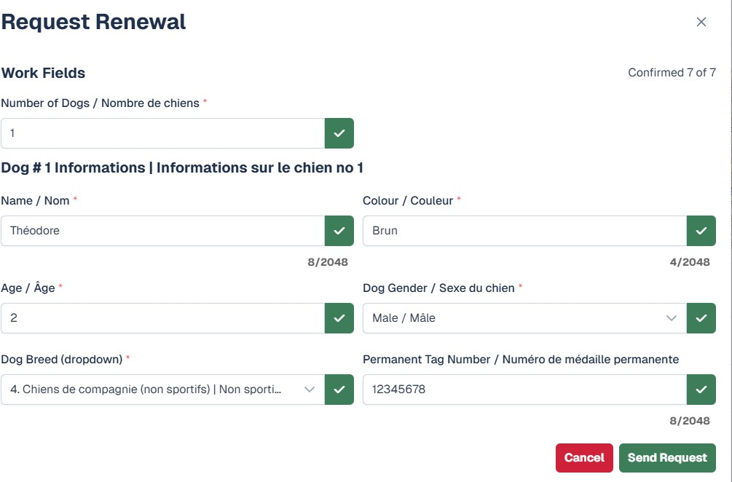
The dog tag is permanent and does not need to be replaced, but annual renewal is still required.

