

SOP – Submitting a Dog Licence Application through the CityWide Portal

Purpose 2
Target Audience 3
Prerequisites 3
Accessing the CityWide Portal 3
Submitting a New Dog Licence Application 3
Type of Licence 4
Property Address 4
Applicant 4
Application Type 5
Attachments 5
Final summary 5
Confirmation and Follow-Up 6
Annual Dog Licence Renewal 7

Purpose
This document describes the steps residents must follow to submit a dog licence (tag) application to the Municipality of Casselman through the CityWide Client Portal.

Target Audience
Residents who wish to register their dog(s) and obtain an official municipal dog tag.

Prerequisites
- Before submitting an application:
- Have access to an active CityWide account
- Have internet access
- Have the dog’s information on hand

Accessing the CityWide Portal
a. Open the following link in your web browser :
https://citywideportal.com/auth/login

Submitting a New Dog Licence Application
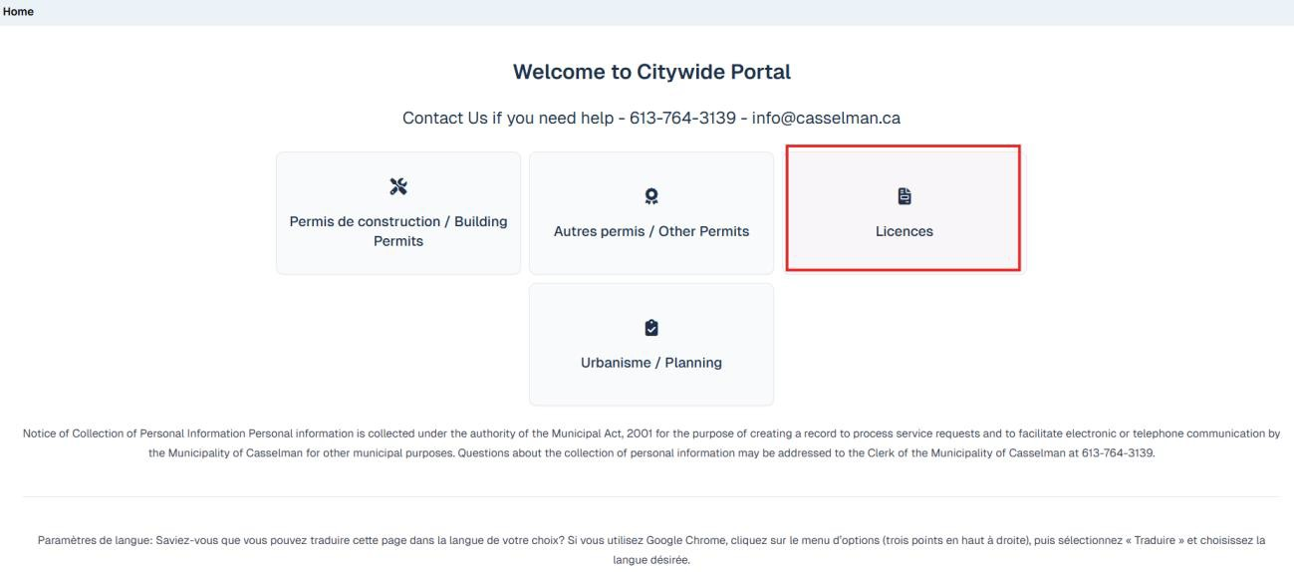
- Go to the Licences module in your dashboard.
- Click ‘New Application’, then confirm your municipality.

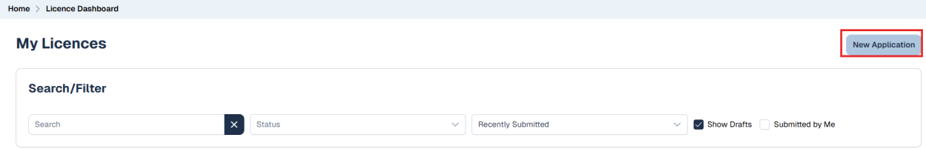
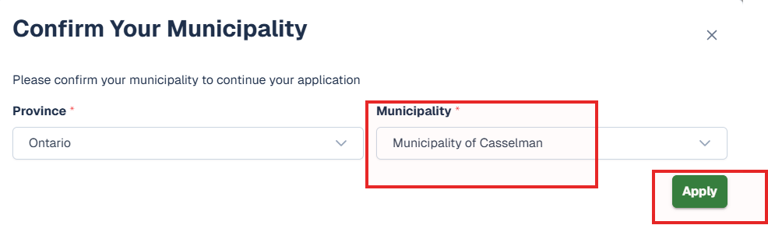

Type of Licence:
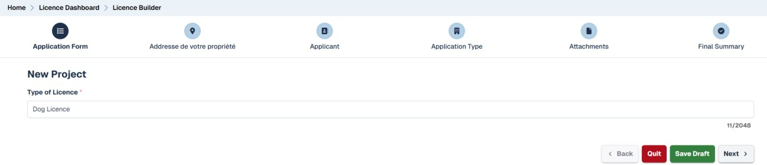

Property Address:
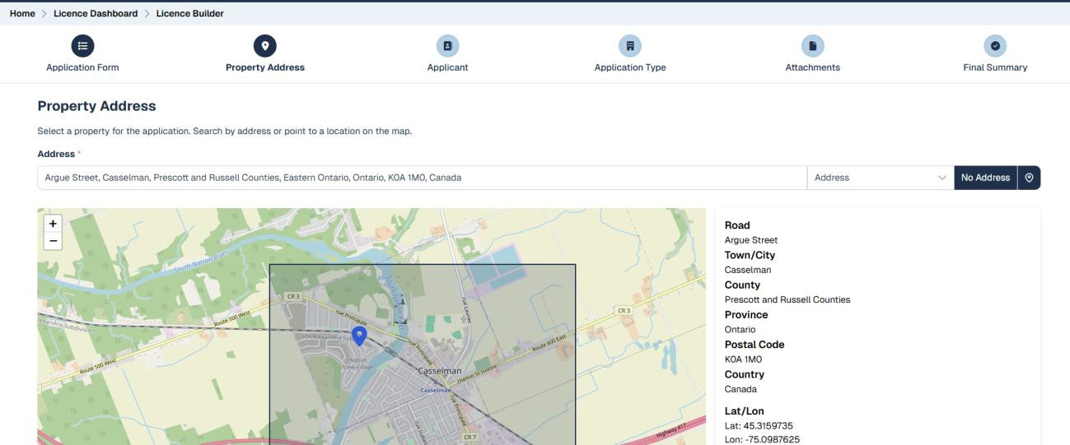

Applicant:
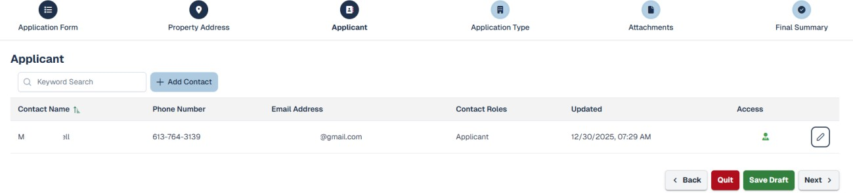

Application Type
- Select the Licence Type for :

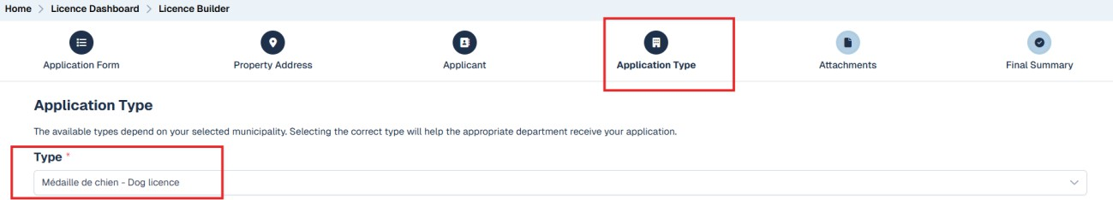
Dog Licence
- Complete all required fields (marked with a *).
- You may enter up to three dogs per property.

Attachments

- No documents are required unless the municipality requests proof (e.g., guide dog/service dog).

Final summary
- Review all information and click 'Submit' to send the application to the Municipality.

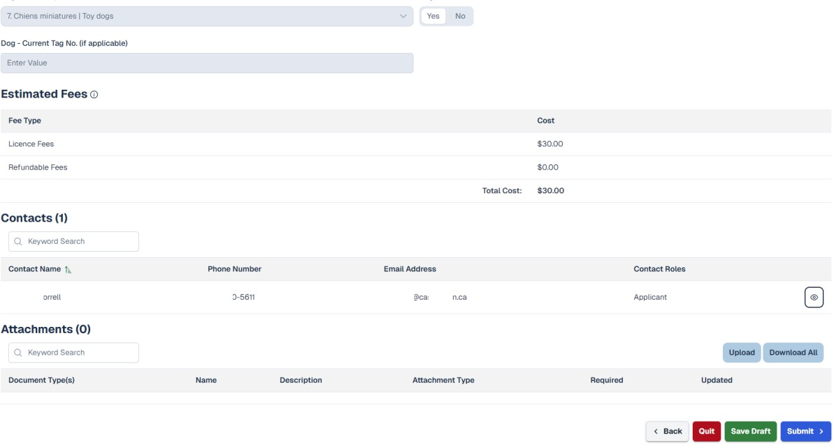
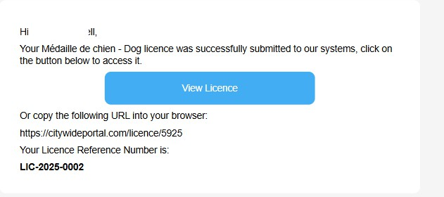
- A confirmation email will be sent once the request is received.
- After submission, the application will appear in your CityWide Licence dashboard.
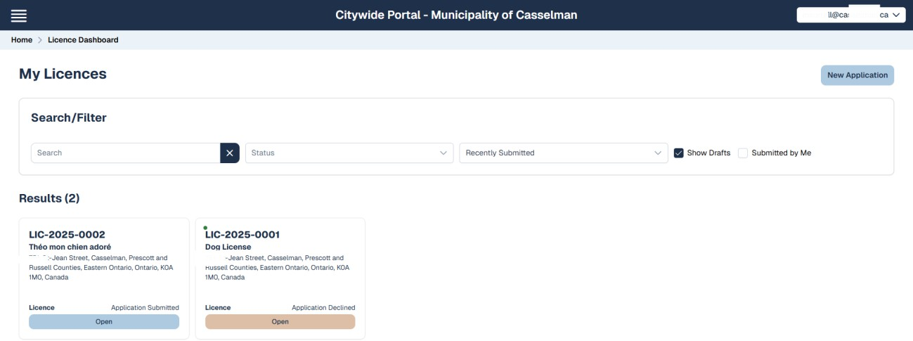

Confirmation and Follow-Up
Once your application is reviewed by the municipality, you will receive a notification with payment instructions.

Annual Dog Licence Renewal

Property Owners in Casselman
Property owners who registered their dog in CityWide do not need to submit a manual renewal.
  - The renewal fee will be automatically added to your annual tax bill.
  - No action is required in the CityWide portal once the initial registration is completed.
  - The dog tag issued at registration is permanent and does not need to be replaced each year.

Tenants
Tenants must renew their dog licence each year through the CityWide portal.
  - Log in to your CityWide account.
  - Open your existing dog licence file.
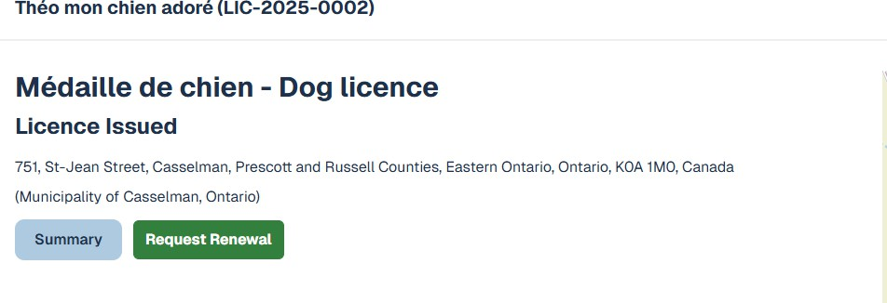
  - Click “Request Renewal”.

  - Review and validate your information (each field must be clicked to confirm).
  - Submit your renewal.
  - Follow the payment instructions sent by the municipality.

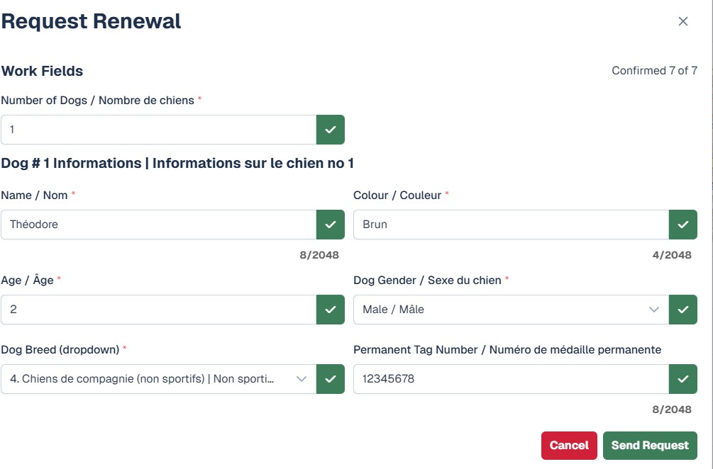
The dog tag is permanent and does not need to be replaced, but annual renewal is still required.

