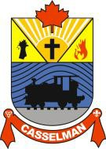

Access Guide to CityWide

Goals 2
Public 3
Pre-requisite Before Getting Access to System 3
Access to Portal 3
Create an Account 3
Connecting to Portal and Updating Your Profile 4
Using Google Chrome to Translate the CityWide Portal……………………………………………………………5

Goals

This document explains the steps to create an account in the CityWide portal, allowing residents to access the

online services of the Municipality of Casselman.

Public

Any resident wishing to use the CityWide portal to submit municipal requests.

Pre-requisite before getting access to the system
- Have a valid email
- Have access to the Internet

Access to Portal
a. Open the following link in your web browser :
https://citywideportal.com/auth/signup

Create an Account
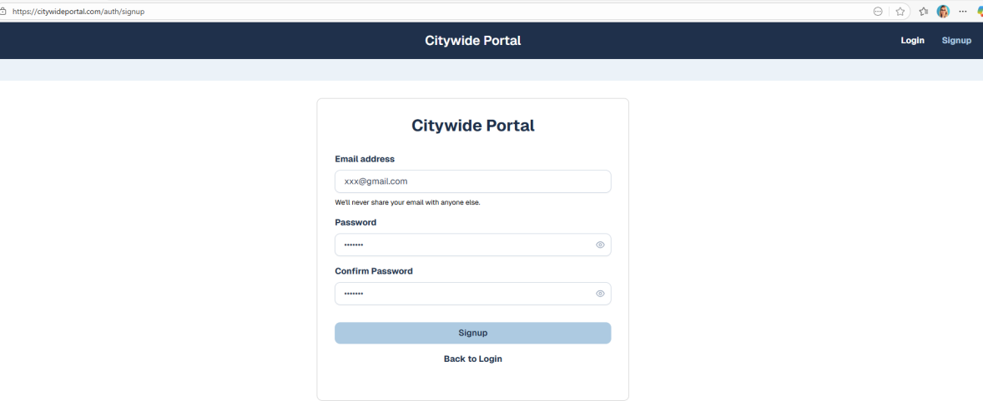
- Click on “Create an account” if you don’t already have one.
- Fill in the required information (name, email, password, etc.).

- Confirm the creation of your account by clicking on the validation email in your mailbox.

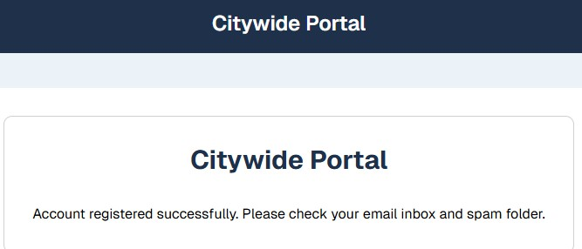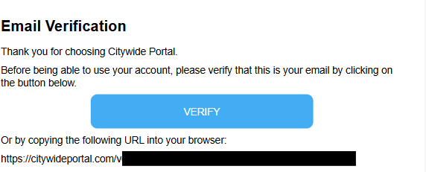
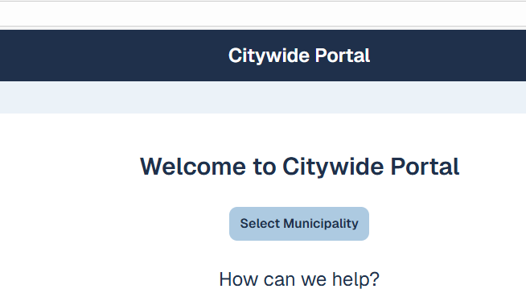
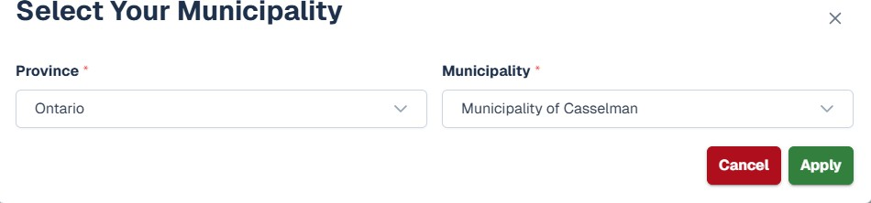
- Select your municipality

Connecting to the portal and update your profile
  - Enter your email and password
  - Access the client dashboard

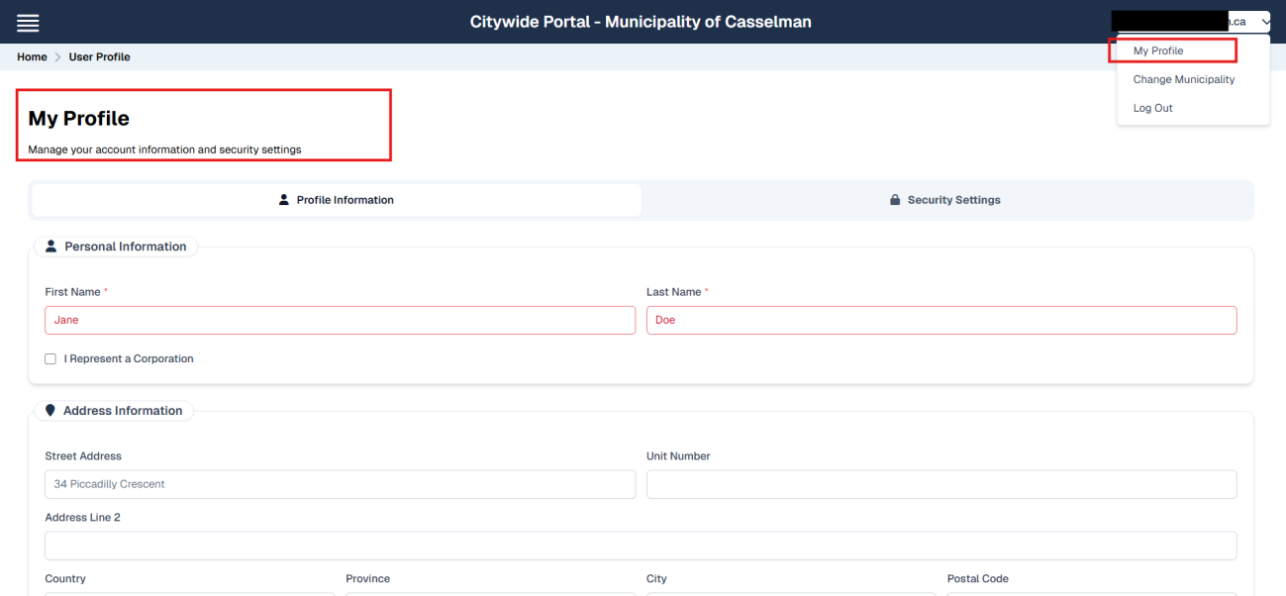
  - Top right of the page, under your email address, you can update your profile. This step is mandatory before you can submit your first application through the portal. .

Using Google Chrome to translate the CityWide Portal
If the CityWide Portal is in English, Google Chrome can automatically translate the page.
How to translate the portal with Google Chrome:
- Open the CityWide Portal page
- Right-click anywhere in the page.
- Select ‘Traduire en français’.
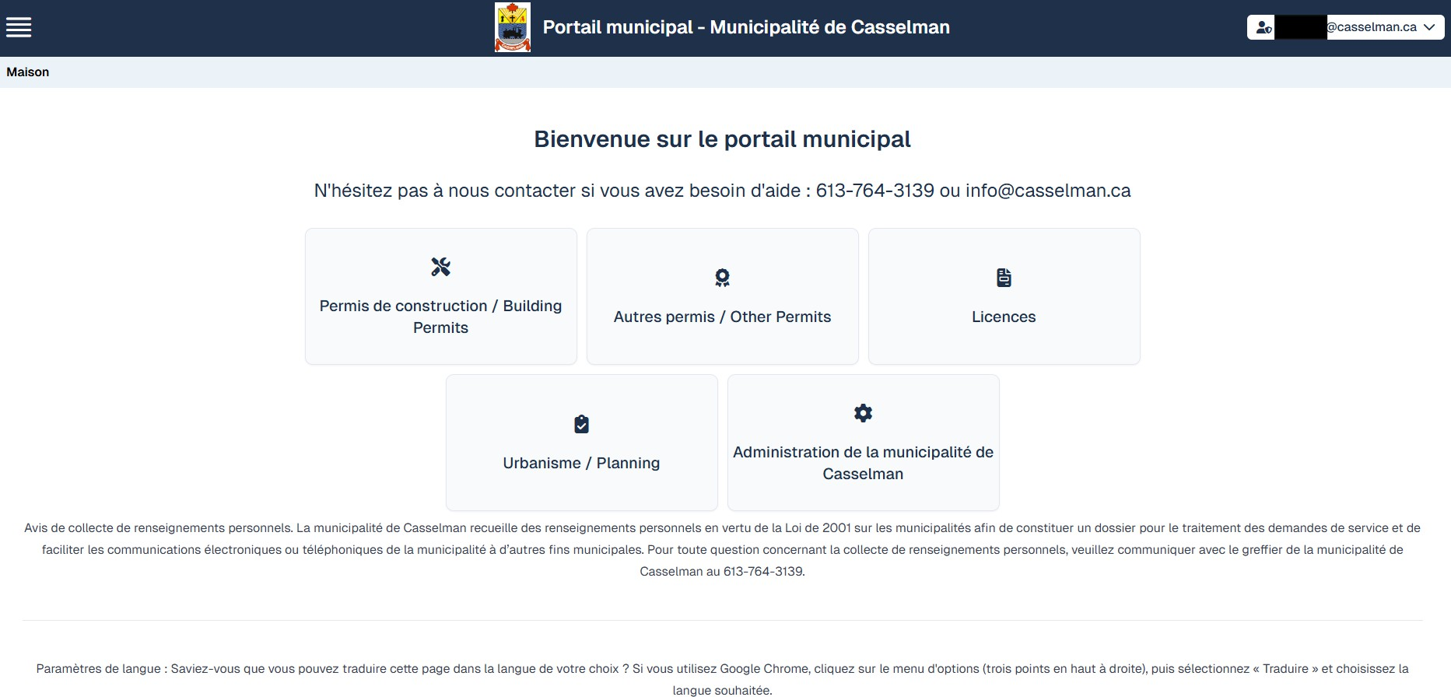
- If needed, click on the translation icon in the address bar to change language.
- The page will refresh in the language of your choice.

